Moscarini and Postel-Vinay (2016) present a model where, under wage posting and a non-binding reservation wage (R), wage growth depends on worker employer-to-employer (EE) transitions, not transition from unemployment to employment. The basic set up of the model is that firms vary by productivity and this determines the wage they pay. The same wage is paid to all workers within the firm. Setting the wage determines firm size (number of workers), with firms that pay more being able to attract more employees. These new employees were either previously unemployed or working at a firm that paid a lower wage. Each employer can also lose workers due to either normal attrition or to firms that pay higher wages.

Workers randomly draw offers and unemployed workers accept an offer if it higher than their R. Employed workers accept if it higher than their current wage. The two important parameters to mention are λ0 and λ1. The λ0 (λ1) parameter represents the rate at which the unemployed (employed) workers sample the randomly drawn job offers. As previously mentioned, wage determines firm size - you can think of λ0 and λ1 as representing the strength of this size-wage relationship. For example, if the two parameters are low, workers are not very responsive to higher wages and it is difficult for firms to attract more of them.

These two parameters also determine the wages that firms pay. According the model, the parameter λ1 should exhibit a positive correlation with worker wages. If it increases, for any wage raise it is now possible to attract more workers. Conversely, any wage decrease will result in more workers leaving for higher paying opportunities. Therefore, the marginal benefit to higher wages has now increased. The λ0 parameter only affects wages through the R necessary to attract an unemployed worker, with higher λ0 resulting in higher R. The reasoning for this is simple, it is not necessary to pay these workers a higher wage to induce them to work for the firm. Therefore, for wage competition above R, λ0 plays no role in wage setting.

To test the model empirically, they use the job switching rate (the fraction of employed workers who change employers without going through unemployment) as a proxy for λ1. The proxy for λ0 is the job finding rate of the unemployed. They run very simple regressions where they first show that the unemployment exit rate is positively correlated with wage growth. However, when the employer-to-employer job flows are accounted for, the unemployment exit rate is either not statistically significant, negative or greatly reduced in size. Again, the models are very simple and not worth describing in detail. I have posted Table 1 below as an example (note: ECI = Employment Cost Index).

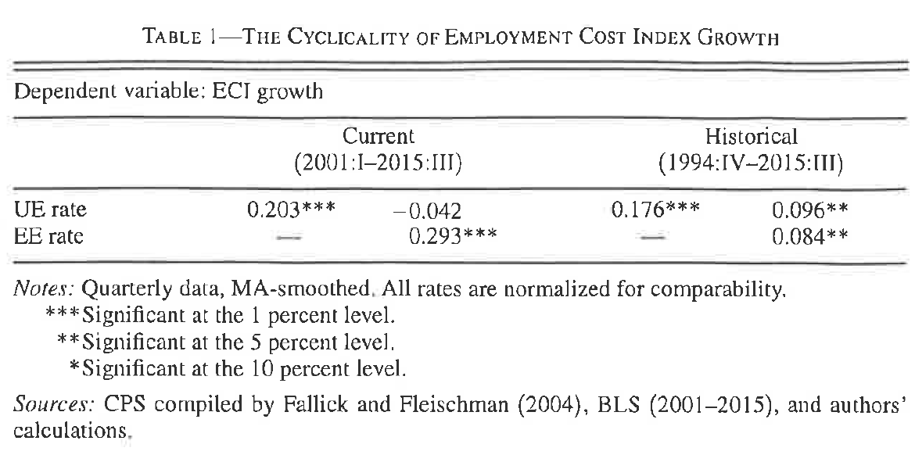

* Set up
  + According to economic theory wage discrimination is not likely to persist in a competitive economy. Higher profits can be achieved by hiring members from discriminated groups.
  + However, the empirical existence of unexplained wage gaps is difficult to reconcile with theory or competitive markets.
  + The authors present a theoretical model in which wage posting prevents firms paying different wages based on race. Therefore, the market response of a firm, to hire discriminated applicants at a lower price, cannot function.
* Model Basic 1
  + In this model there are two types of workers, white and black.
  + Workers apply to firms that post vacancies. One worker is hired by the firm, the rest are now unemployed. Firms that do not attract an applicant are now idle.
  + If both black and white workers apply to a firm, only white workers are hired. This is because in the model white workers have slightly larger productivity or firms are biased against black workers.
  + If “discrimination” is modelled as productivity difference then firms maximize profitability.
  + If “discrimination” is modelled as racism and black and white workers are equally productivity, then firms maximize utility.
  + This distinction, between racism and productivity does not change the results.
  + However, it does mean that the model is able to explain the wage gap between black and white workers either through discrimination or small productivity differences.
  + This does mean that the empirical predictions of the model, if observed can be attributed as being solely to either racism or productivity differences.
* Model Basic, 2
  + The workers expected income is based on two factors: the wage they earn and the probability they will get hired.
  + There is a tradeoff between applying to higher wage firms and the probability of getting hired. This is because higher wages attract more applicants.
  + The firms expected income is based on two factors: the profits they make (productivity – wage) and the probability they will have a worker apply.
  + There is a tradeoff between having higher profits (through lower wages) and the number of applicants.
* Segregation
  + There are not only two types of workers, but also two types of firms. Ones that hire only black workers and ones that hire only white workers. This is not an explicit policy, but rather due to the wages they offer.
  + To understand this, consider the decision to apply to a firm for white and black workers. White workers base their decision based on the wage and the number of white applicants. They do not consider black applicants, because they will always be hired ahead of them.
  + On the other hand, black workers have to consider both the number of white and black applicants as well as wages. The probability that a white applicant might apply to the job greatly reduced the expected income from applying to it.
* Vacancies and Race (incidental)
* Losers and winners